JAVA String Concept

# String Introduction

* String is non premitive data types because it references a memory location where the data is stored in the **heap memory** or **String Constant pool**
* It references to a memory whether an object is actually placed
* So that the variable of a non primitive data type is also called the **reference** data types or object reference variable.
* All non primitive data types are simply called **objects** which are created by instantiating a class
* String ka **size** fixed nahi rahta
* String is the squence of the character or **array of character**
  + - **char**[] ch={'j','a','v','a','t','p','o','i','n','t'};
    - String s=**new** String(ch);
* Java ke under charSequence name ka interface hota hai jiske vajah se hum char ko represent kar skte hai
* String name ki class java me pahle se hi bani hui hai and uske bahut sare methods pahle se defind hai

**Public final class string extends object**

**{**

**}**

**String class ka syntex yeh hai and interview me puchha jata hai ki why string class is final**

* String class ka parent class object hai so voh object class ko inherit karta hai
* String class implements **Serializable, Comparable and CharSequence interface.**
* String ek class hone ke vajah se hum uska object bana skte hai
* **String c = new String();**
* **Jaha c hume ek immutable empty object bana ke deta hai**
* So string is the immutable object
* String create karne ke liye java me 3 classes hai 1) String 2) StringBuffer 3) StringBuilder
* StringBuffer and StringBuilder class ki helps se hum **mutable** object bana skte hai
* String class se hum **immutable** object bana skte hai

# Creating immutable String in Java

* There are two ways to create a string in Java:
* Using String Literal -> String str1 = "Python";
* Using new Keyword-> String str1 = new String ("Java");

# Memory Area in Java

Java ke under 5 type ka areas bane hue hai

1) Method Area

2) Heap Area

3) Stack Area

4) PC Register

5) Native Method Area

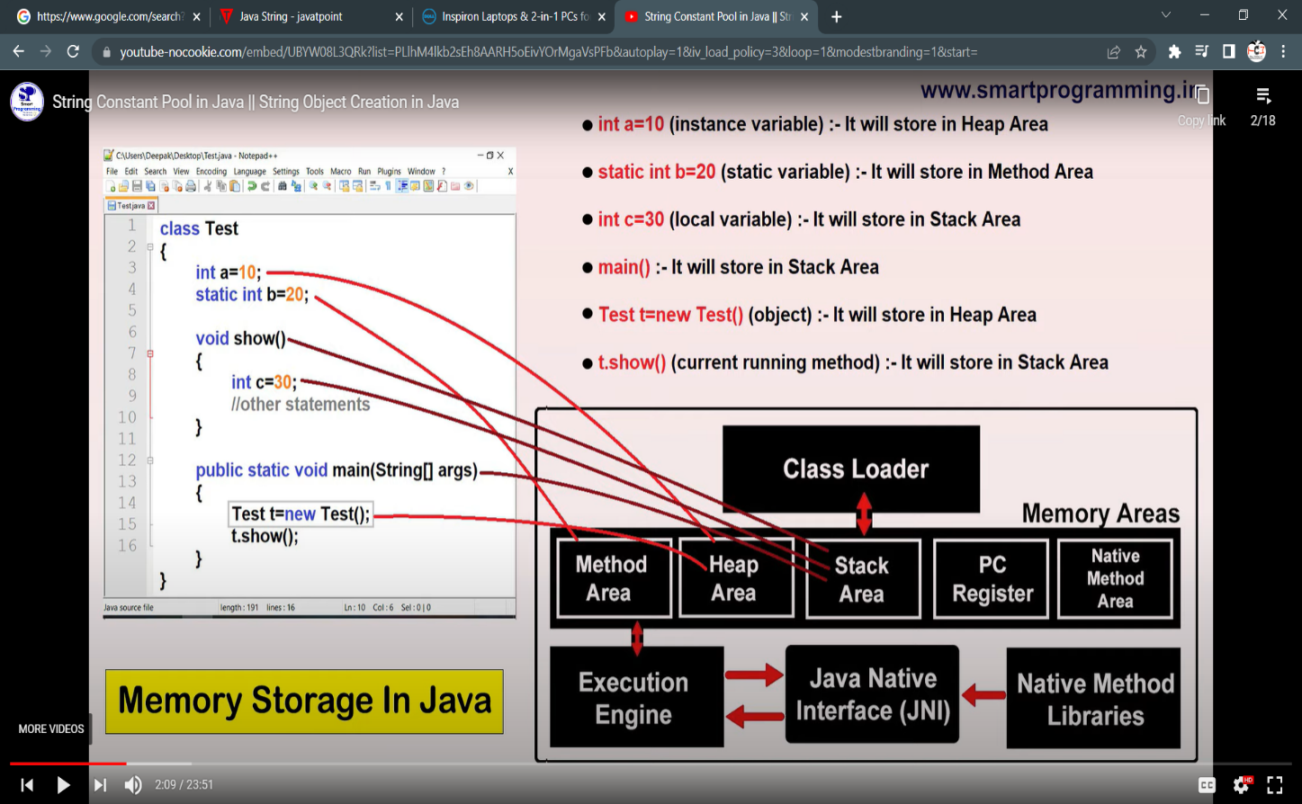

# String Constant Pool

* A “string constant pool” is a separate place in the heap memory where the values of all the strings which are defined in the program are stored.
* 1.6 version tak “scp” method Area me tha but after 1.6 version “scp” ko “heap Area” me transfer kar diya gya because method area me “scp” ka size fixed rahta tha andt heap area me jaise hi scp aaya to voh apne size ko dynamically increase or decrease kar skta hai

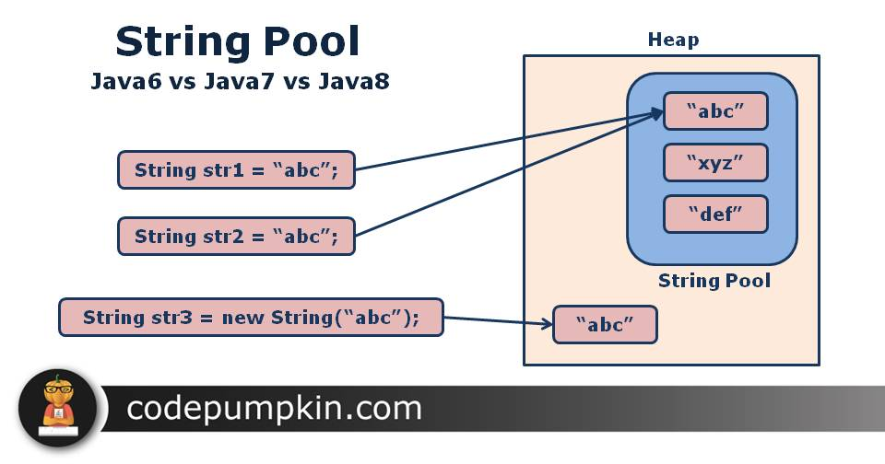

* String a = new String(“Rishikesh”);

Aisa likhne se Rishikesh name ka object heap and “string constant pool” dono me create ho jayega

* But String b =”Ram”;

likhne se voh sirf “string constant pool” me hi create hoga

**Note : new keyword ka use karne par 2 time object create hota hai isliye hum string ko new keyword ki help se jada create nahi karte hai because voh jada memory ocupied karega.**

* Heap area ke under Garbage collection ka concept lagta hai but SCP me Garbage collection ka concept nahi lagta because ek baar SCP me object create hota hai to usse hum delete nahi kar skte hai because of “ reference variable” ko internally JVM ;point out karta hai
* And “string constant pool” me likhe hue object ko hum future me use kar skte hai.

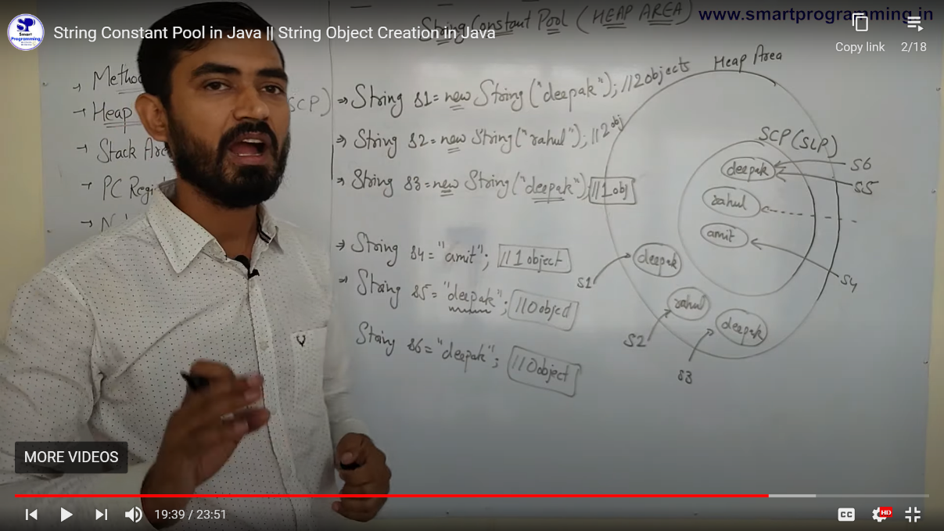

# String Object Are Immutable

* String **is immutable which means it cannot be changed**. Whenever we change any string, **a new instance** is created.

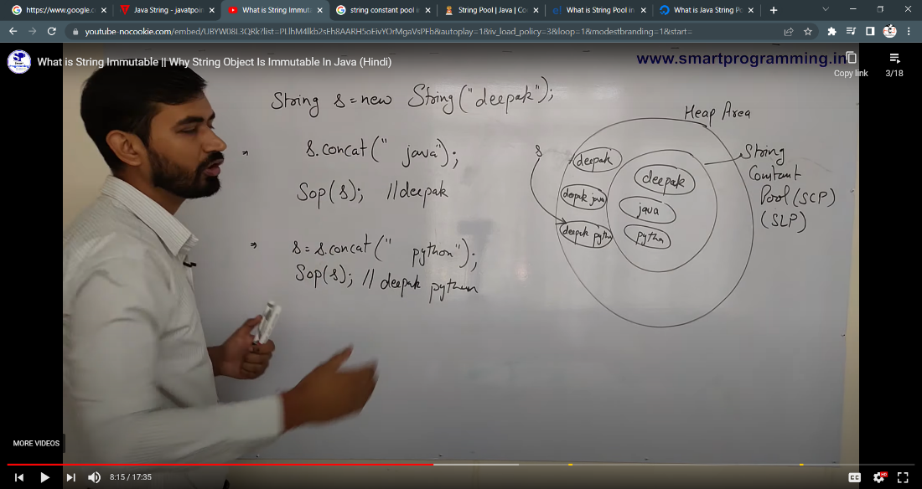

# String Constant Pool ke benefit

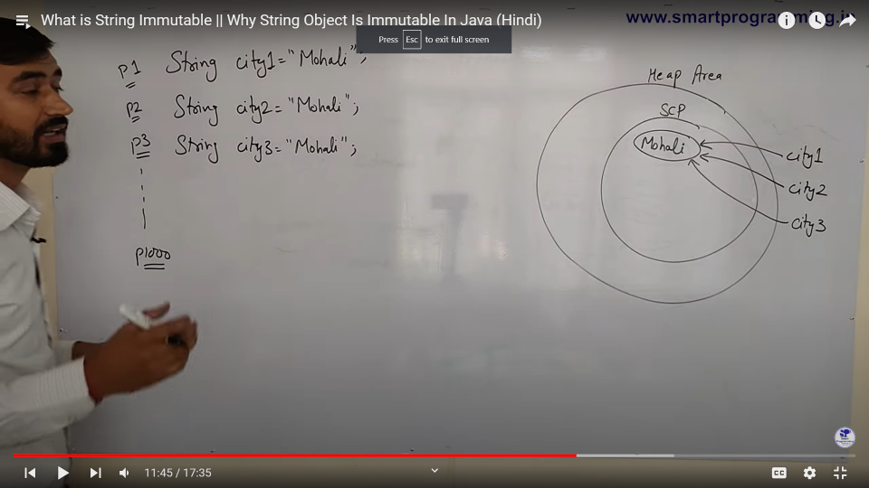

* Yaha par agar 1000 people mohali me rahte hai to 1000 time mohali “string constant pool” me store nahi hoga sirf 1 time hi store hoga and 1000 object usse point out karege jisse humhara project fast run karega
* Agar person 3 apna city change karke mohali se delhi change karta hai to “string constant pool” me delhi name ka object create ho jayega and city3 object ab delhi ko point out karega

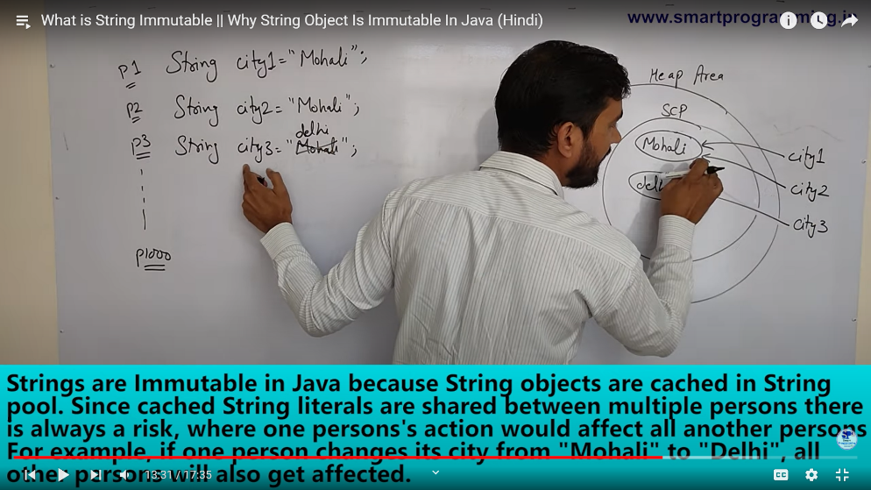

* SCP me create hue object future me use kiye jate hai isliye voh immutable hote hai
* String immutable ka meaning hai ki hum usski value ko change nahi kar skte balki voh ek new object create kar dega

# Why String class is final

* Final ek keyword hota hai
* Jo class ,method or variable ke sath use kiya jata hai
* Agar meri class final hoga to uss class ko koi bhi extends nahi kar skta.

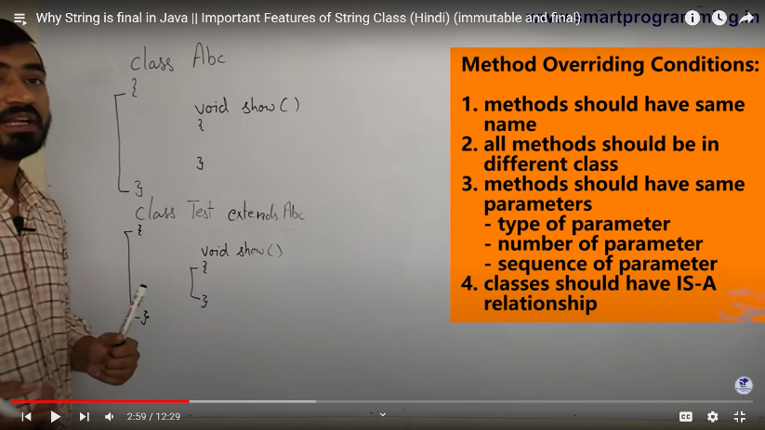

* Agar parent class ke method ko final bana diya to koi bhi child class uss method ko overide nahi kar skta
* Final **a** =5; likhne se **a** variable ki value fix ho jati hai and ab koi **a** ki value ko change nahi kar skta
* Isliye java me string class final hota hai jisse koi bhi developer string class ko inherite karke usske value ko change na kar ske

# Importance of String class

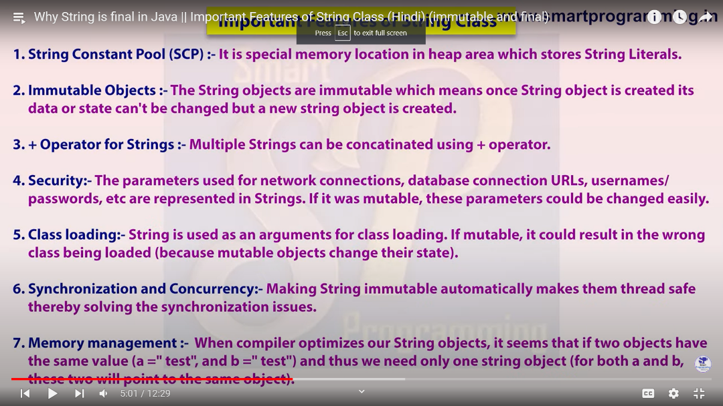

# String constuctors

* **Impotance 6 constructor lists**

1)public String()

2) public String (String s)

3) public String (StringBuffer sb)

4) public String(StringBuilder sf)

5) public String (char [] ch)

6) public String(byte []b)

* String sd = new String();

yaha ek empty string create ho gya hai

* String sa = new String(“rishikesh”);

yaha sa yah rishikesh object kopoint out karega

* StringBuilder sd = new StringBuilder(“Shivani”);

String ss = new String(sd);

Yaha humne ek mutable object ko immutable object me create kiya

* StringBuffer sd = new StringBuffer (“Shivu ”);

String ss = new String(sd);

Yaha humne ek mutable object ko immutable object me create kiya

* Byte [] b ={101,102,103};

String s2 = new String(b);

Sop(s2);

Output**: efg**

Yaha string ne 101 ki value ko **e** , 102 ki value ko **f** and 103 ki value ko **g** print karvaya hai

# Password ko hum char [] me store kiya karte hai nki string me

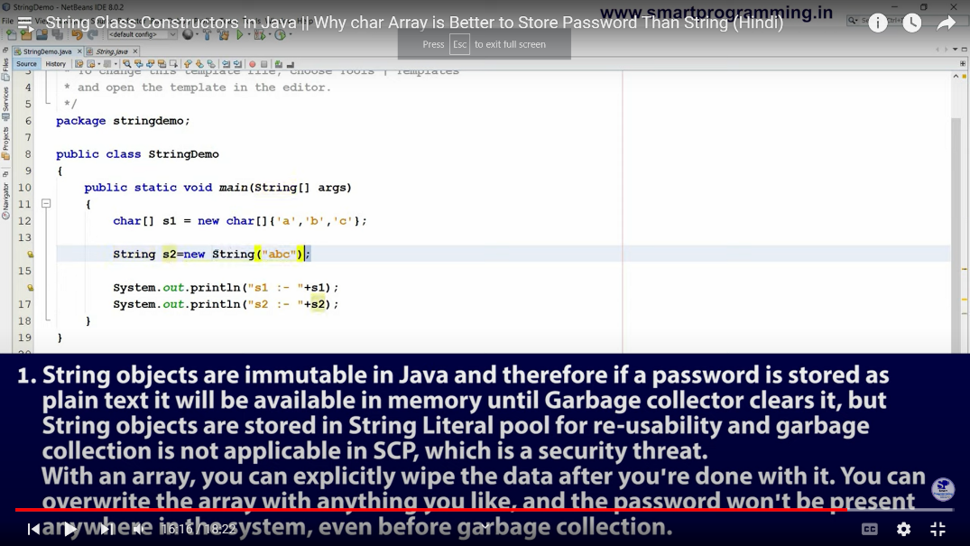

* **Note:** Ek baar program ko run karke dekhna to idea aa jayega ki humm password ko string me kyu nahi likhte hai ex me password = abc hai

# Strings methods

## 1) == Operator

* Yeh ek operator hai.
* iska use reference comparision or address compariation ke liye kiya jata hai
* == operator is used to check the reference of both the string objects

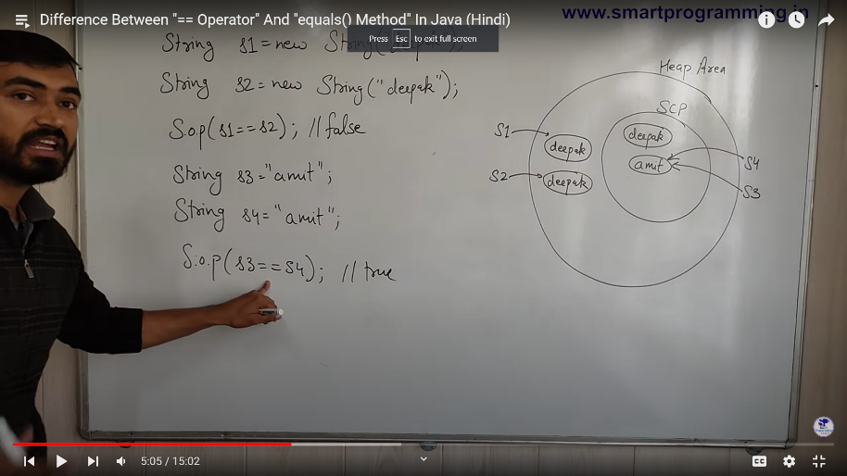

## 2).equals()

* Yeh ek method hai
* yeh actual me **object** class ka method hai n ki **string** class ka but string class ne uss method ko overide kar liya hai and jiske vajah se yeh sirf content comparision ke liye use kiya jata hai

Uper ke example me **s1.equals(s2)** ka ans **true** aayega bcoz dono me **deepak** name hi likha hua hai.

-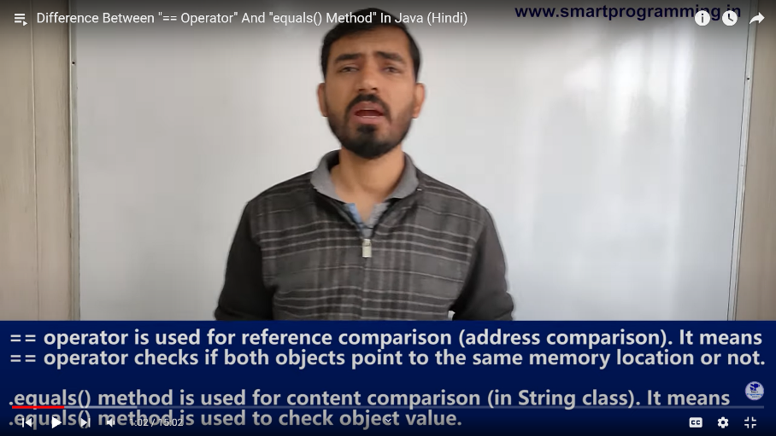

## 3).length();

* Yeh integer me output deta hai

**Note : example**

**String** name = null;

System.out.println(name.length());

**Output:** null point exception aayega

Kyu ki null ke liye yeh method nahi use kiya jata hai

## 4).isEmpty();

* Yeh ek boolean value dega.
* null ke liye yeh method nahi hai and yeh exception dega

## 5). trim();

* Yeh hume string me value deta hai
* Yeh sirf aage and pichhe ke white space ko remove karta hai n ki bich vale

## 6).equalsIngnoreCase ();

* Yeh ek boolean value dega.
* String s1= “Rishikesh”;

String s2 = “rishikesh”;

S1.equalsIngnoreCase(s2);

**Output:** true

## 7) .compareTo();

* yeh method hume int me value deta hai
* yeh character ko pahle asci code me convert kar ke compare karta hai pahele voh dono string ke first character ke ASCI value ko dekhega agar dono same hai next character ko check karega

1) String st1 = **new** String("INDIA IS MY COUNTRY");

String st2 = **new** String("india is my country");

System.out.println(st1.compareTo(st2));

Output : -32

**Note :** yeh sirf pahle first character ko dekh ke hi output show kardeta hai but first character same hai to fir voh second character ko dekhega and output show karega

2) String s1="hello";

String s2="";

System.out.println(st1.compareTo(st2));

Output : 5

**Note:** jub second string empty hoto voh sirf length check karta hai and output deta

Hai

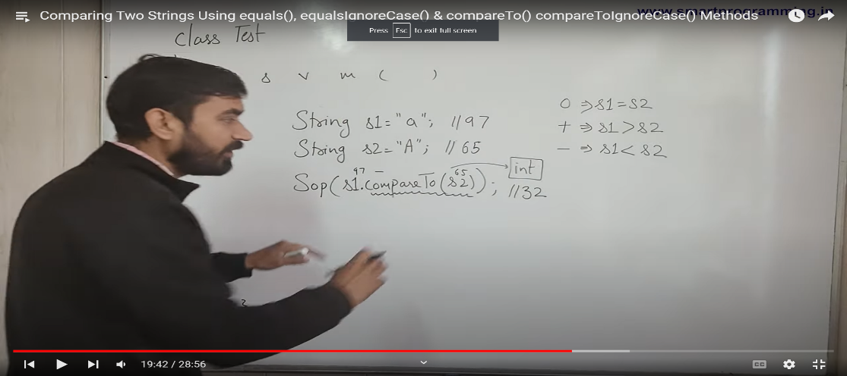

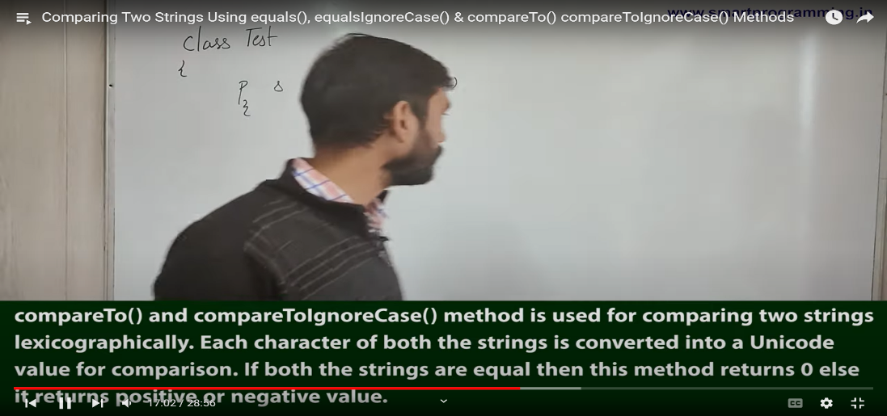

## 8) .compareToIgnoreCase();

* yeh string ko lowar case me convert karke fir voh compareTo method apply karta hai

## 9) +operator();

* yeha + symbol ka use hota hai.
* 1) String s=50+30+"Sachin"+40+40;

**Output:** 80Sachin4040

* Yaha BODMAS ka concept lagta hai
* 2) String s =”Rishi”

System.out.println(“Rishi”+4-7);

**Output:** error dega

## 10) Concat();

* String s = "Hello ";

s = s.concat("World");

System.out.println(s);  
 Output:HelloWorld

## 11)Java String join();

* The **Java String class join()** method returns a string joined with a given delimiter. In the String join() method the delimiter is copied for each string.
* Yeh java ki static method hai and jo bhi iske delimiter me likha hota hai voh usse har string ke bich me add kar deta hai.
* **note** agar delimeter ke place par null value dala to exception throw kar dega.

String joinString1=String.join("-","welcome","to","javatpoint");

System.out.println(joinString1);

Output : welcome-to-javatpoint

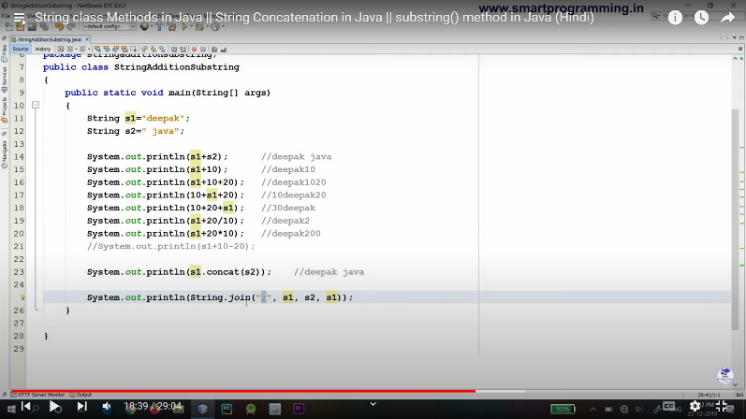

## 12)subSequence();

* Note last vale value se ek kam lena hota hai
* String Str = "Welcome to geeksforgeeks";

System.out.println(Str.subSequence(1, 5));

Output : elco

## 13)substring();

* **startIndex:** inclusive
* **endIndex:** exclusive
* 1) String s="hellomyname";

System.out.println(s.substring(0,2));

Output: he

2) System.out.println(s.substring(3));

Output : lomyname

## 14)replace();

* The **Java String class replace()** method returns a string replacing all the old char or CharSequence to new char or CharSequence.

**public** String replace(**char** oldChar, **char** newChar)

* String s1="javatpoint is a very good website";

String replaceString=s1.replace('a','e');//replaces all occurrences of 'a' to 'e'

System.out.println(replaceString);

* Output : jevetpoint is e very good website
* NullPointerException: if the replacement or target is equal to null.

## 15)replaceFirst();

* String str1 = "aabbaaac";
* System.out.println(str1.replaceFirst("aa", "zz"));
* Output zzbbaaac

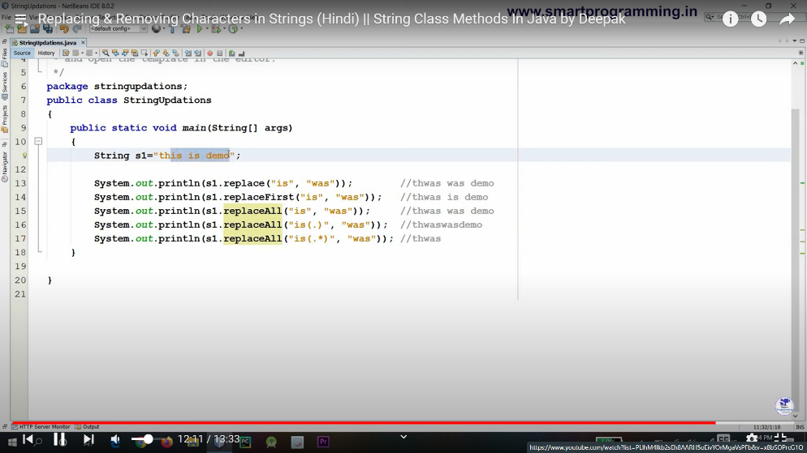

## 16)replaceAll();

* public String replaceAll(String regex, String replacement)
* **regex** − the regular expression to which this string is to be matched.
* **replacement** − the string which would replace found expression.
* **Note**: youtube par ek baar check kar lena
* **Video no 10 hai**

# Strings Searching methods

## 1)indexOf();

* Yeh ek int value return karta hai
* Agar usse value nahi milta hai to voh -1 return kar deta hai
* Iske argument me hum string ya character dono mese koi bhi value de skte hai
* 1) String myStr = "Hello planet earth, you are a great planet.";

System.out.println(myStr.indexOf("planet"));

* Output : 6
* 2) String AK = "Hello planet earth, you are a great planet.";

System.out.println(AK.indexOf("e", 5));

* Output :10
* Note yaha voh 5th index ke baad search karna start karega usse pehle ke character ko voh ignore kar dega

## 2)lastIndexOf();

* Yeh ek int value return karta hai
* Agar usse value nahi milta hai to voh -1 return kar deta hai
* Iske argument me hum string ya character dono mese koi bhi value de skte hai
* 1) String myStr = "Deepak";

System.out.println(myStr.lastIndexOf("e"));

* Output : 2

## 3)charAt();

* Yeh ek int value leta hai
* Yeh character value return karta hai
* 1) String myStr = "Deepak";

System.out.println(myStr.charAt(4));

* Output : a

## 3)contains();

* Yeh ek character value leta hai
* Yeh boolean value return karta hai
* 1) String myStr = "Deepak";

System.out.println(myStr.contains(“pak”));

* Output : true

## 4)startWith();

* Yeh ek character value leta hai
* Yeh boolean value return karta hai
* 1) String myStr = "Deepak";

System.out.println(myStr.startWith(“e”));

* Output : false

## 5)endWith();

* Yeh ek character value leta hai
* Yeh boolean value return karta hai
* 1) String myStr = "Deepak";

System.out.println(myStr.endWith(“k”));

* Output : true

# Strings Conversion methods

## 1)toUpperCase();

* Yeh upper case me convert kar deta hai
* String as = “rishikesh”;

System.out.println(as.toUpperCase());

* Output : RISHIKESH;

## 2)toLowerCase();

* Yeh upper case me convert kar deta hai
* String as = “RISHI”;

System.out.println(as.toLowerCase());

* Output : rishi;

## 3)valueOf);

* Yeh kisi bhi ek data type ke value ko string me convert kar deta hai
* Yeh ek static method hai
* Jiske vajah se hum string class ki help se isse call karte hai
* Int a =5;
* String vv = String.valueOf(a);
* Output : “5”;

## 4)toCharArray();

* Yeh string ki value ko char array me convert kar deta hai
* String aaa = “RIshikesh”;
* Char [] c= aaa.toCharArray();
* Output : R , I,s,h,I,k,e,s,h

# String Buffer Class

* Jab bhi hume mutable object crate karna ho to hum string buffer class ka use karte hai
* Example : Calculator me value humesha change hoti rahti hai isliye iss case me hum string buffer class ka use karege
* String buffer purane string value ke ander change kar deta hai jisse memory jada use nahi hoti hai
* But Name , email, country jaise field ko fill karvane jaise project me hum string class ka use karege
* Becouse string class immutable object create karta hai

StringBuffer aa = new StringBuffer(“Rishi”);

aa.append(“kesh”);

system.println(aa);

Output : Rishikesh ;

* Note yaha rishi object ommit ho gya and uske place par Rishikesh object create ho gya . But agar String class use kiya hota to Rishi bhi raha and Rishikesh bhi rahta
* Java.lang package me hai
* Minimum capacity iski hoti hai 16
* Agar old capacity 16 se jada bhar gai to vah apni capacity ko -> (old capacity *2)+2 kar geda

Ex (16*2)+2= 34

Agar 34 capacity bhi bhar gai to fir voh (34*2)+2= 70 kar dega

* Interview me .length(), .capacity() dono method me kya anter hai puchha jata hai
* Uper ke example se aa kitne character ko store karva skta hai yeh uski capacity hai and aa variable me jo object hai uski size kya hai voh length method bata hai
* Append iska method hai

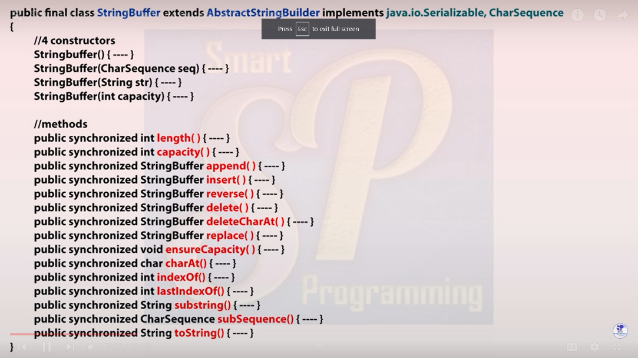

* Yaha .equals method false dega because of .equals method ye object class ka method hai and stringBuffer uss method ko override nahi karta hai jiske vajah yeh method address ka comparition karta hai jiske vajah se ans false aayega
* Object class me .equals methods address ka comparision karta hai String class me .equals methods value ka comparision karta hai.

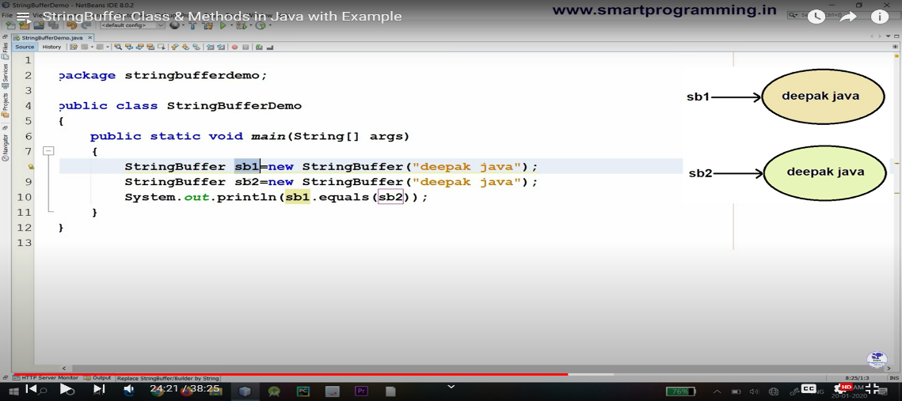

* Next example me ans true aayega

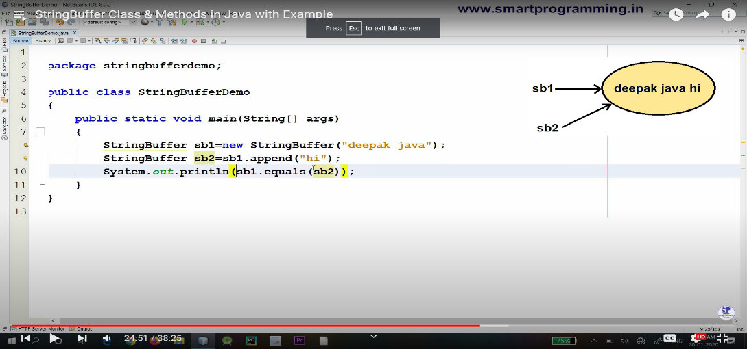

* Reverse method iska ek method hai jo string class me nahi hai
* Note: string buffer ke kafi sare methods jo kafi use hota hai so please refere it
* stringBuffer me jitne bhi methods hai voh synchronized methods hai jiske vajah se uske performance par effect padta hai synchronized methods ke vajah se yeh threads safe methods ho gye jiski vajah se iska performance speed slow ho jata hai

# String Builder Class

* yeh bhi same string buffer ke tarah hi kaam karta hai
* iska introduction jdk 1.5 me hua tha
* yeh bhi mutable object banata hai
* iske under bhi string buffer ke hi sare methods and constructor use hote hai
* String buffer ke method synchronized the but iske method non synchronized hai jiske vajah se iski speed jada hoti hai compare to string buffer

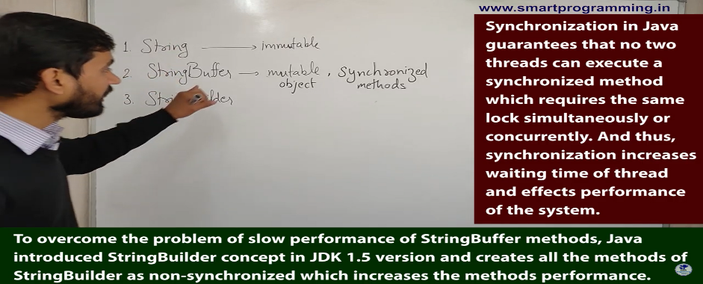

# Difference between String, String buffer and String Builder Class

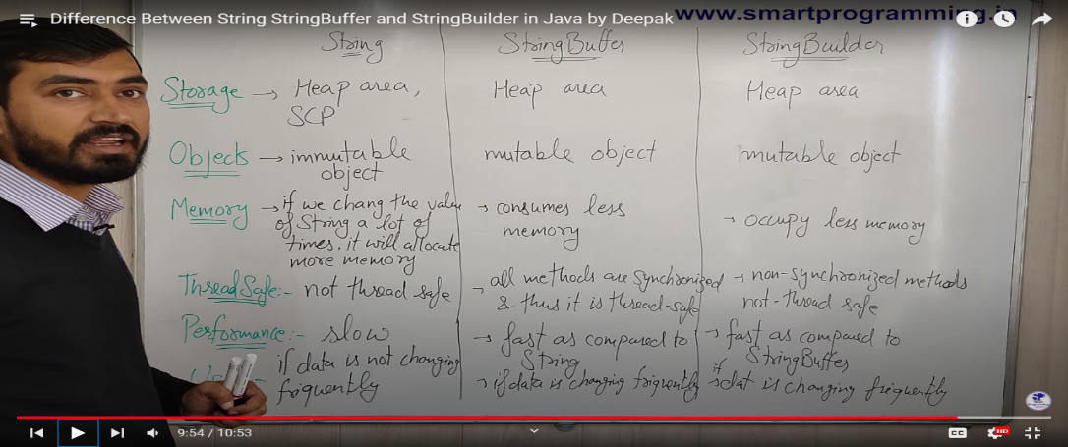

# Revese the string program

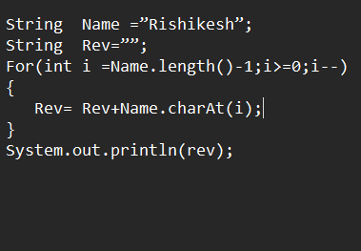

# Program for Paliendrome no

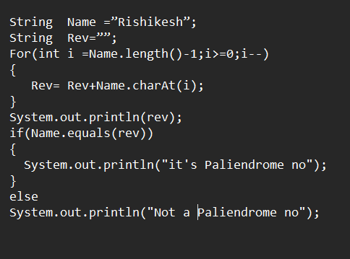

# Pragaram for maximum character in the given String

